7-H/7-S FOAM TRAY
MEAT PACKAGING
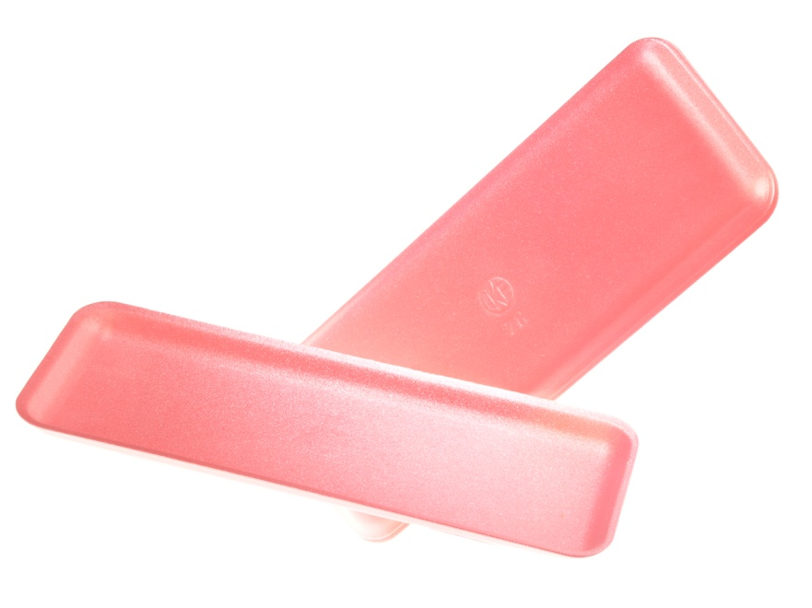

Product Specifications
Description: | 7-H/7-S FOAM TRAY  MEAT PACKAGING | SKU Number: | 87952
Case Dimensions: | 38.1x73.7x29.2 CM  14.9x28.7x11.4 IN | Cubic Meters: | 0.08
Product Dimensions: | 14.8x37.5x1.6CM  5.8x14.8x0.6IN | Weight Per Case: | 2.71KGS  5.962LBS
Product Per Case: | 250
Available Colors: | White – 88107 Blue - 88007  Black – 87807 Aqua - 88207  Rose Pink – 87952 Dark Rose – 88063

