EC801
PULP PACKAGING TRAY
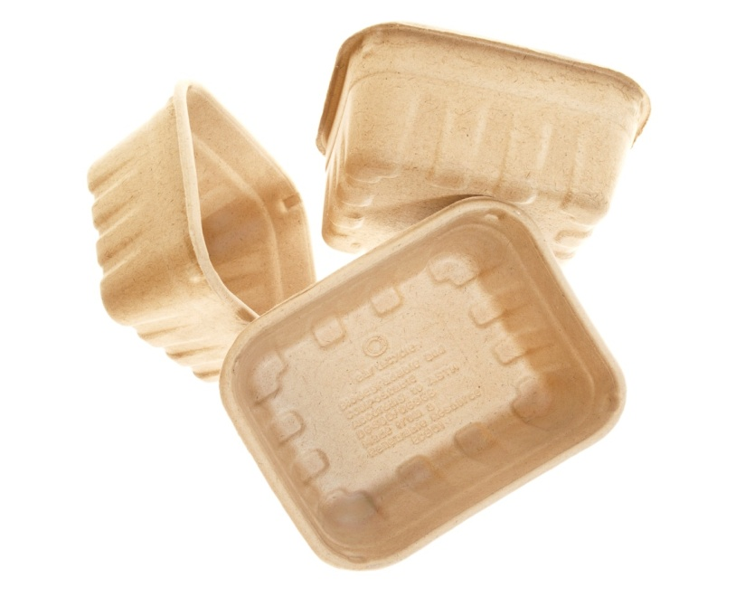

Product Specifications
Description: | EC801  8 oz pint | SKU Number: | 44779
Case Dimensions: | 64x40x30 CM  25x15.6x11.7 IN | Cubic Meters: | 0.08
Product Dimensions: | 14x12.2x5.5CM  5.5x4.9x2.3IN | Weight Per Case: | 10 KGS  22 LBS
Product Per Case: | 390

